Raffle Management Account and Setting up Merchant Account with Paysafe:

Raffle Management Account

- Email address:____________________________
(This will become the username for the account and in some versions of the shopping cart will be visible to the public.)

- Contact Name ____________________________
(This should be the person who will be managing the Raffle)

- Organization Name ___________________________________

- Charity or Non-Profit ___________________________________

- Shipping and Billing Addresses________________________________

- Organization Phone Number - _________________________________
Payment Processor Approval
- Tax Number (9-digits)____________________________

- *Customer Service Phone Number __________________
(*Appears in shopping cart and on CC statement!!)
- Customer Service Email_____________________________

- An Organization Identifier___________________________
(up to 20 characters that will be the line item on the players CC statement)
- Director Or Trustee full name___________________________

- Position___________________________

- Date of Birth of Director / Trustee_________________________

- Director or Trustee Phone Number________________________

- Current Residential Address of Director Trustee______________________

- (If less than 3 years at this address they need a second address)

- Length of years at address___________________

Security Question / Answer from the following list:
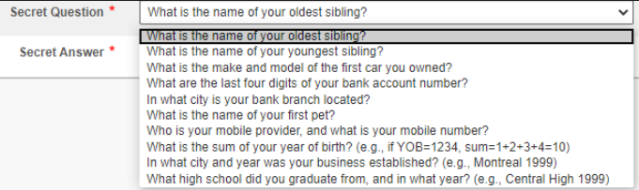

- Average transaction amount______________
(best guess)

- Annual processing amount_______________
(best guess)

In addition we will need the following bank account information:
- Organization Banking Name____________
- Bank Account Number_________________
- Transit ID____________________
- Institution ID___________________
Summary

This is what will need to happen before we go live:
- Raffle Management account setup
- Payment processing application submitted
- Payment processing approval received
- Micropayment deposited in account and confirmed
- Raffle setup
- Live test of raffle

